International

WETA 4.4

Class Rules
2017 V1

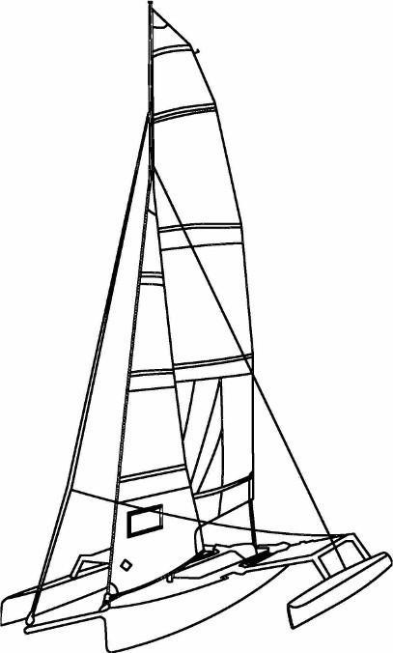

Contents
Introduction 3
1 General 3
2 Construction 4
3 Certification 4
4 Measurer 4
5 Distinctive Marks 4
6 Hulls and decks 5
7 Floats and Beams 5
8 Weight of the boat ready to sail 5
9 Dagger Board 6
10 Rudder 6
11 Mast 6
12 Standing Rigging 6
13 Running Rigging 6
14 Crew 7
15 Sails 7
16 Bowsprit 8
17 Miscellaneous 8
18 Mandatory safety equipment while sailing 9
19 Optional Equipment 9
20 REPAIRS AND REPLACEMENTS 10
21 Grandfathering Clause 10
23 Appendices 11

Introduction
The Weta 4.4 Class is a strict one design class.
The Weta 4.4 is a trimaran developed by Weta Marine, Ltd (New Zealand). The hull, beams, floats, foils, rigging, and sails are produced exclusively by Weta Marine, Ltd, or by their manufacturers under license.
The real test in a one-design race is between crews and not between the boats and equipment. The intent of these rules is to ensure that Weta racing together are as similar as possible in all aspects affecting performance of the boat. Anything that is not expressly permitted by these rules is prohibited.
The hull, beams, floats, foils, rigging, sails, and location of fittings and equipment must comply with specifications and diagrams in these rules. Tolerances are intended to take account of inevitable manufacturing variances and should not be used to alter the construction.
The WCNA may modify these rules in the future to prohibit modifications which are deemed to provide an unfair competitive advantage. Any change in the rules will strive to maintain the competitiveness of boats already distributed, through grandfathering. Owners of boats with subsequently prohibited modifications will bear sole responsibility for bringing their boat into conformity with such changes in the rules.

1 General
- The Weta 4.4 One Design Class is a closed class. This is a restricted manufacture class.
- The intent of these rules is to ensure that Weta racing together are as similar as possible in all aspects affecting performance of the boat.
- Anything that is not expressly permitted by these rules is prohibited.
- Any change in the specifications will strive to maintain the competitiveness of boats already distributed through the grandfather clause (Section 21).
- A Weta 4.4 must race in accordance with all class rules, with hulls, beams, floats, foils, mast and sails provided by the manufacturer [currently : Weta Marine (New Zealand)] or its licensees.
- The hulls, beams, floats, foils, rigging, and sails must comply with the class rules. Measurement tolerances are intended to take account of inevitable manufacturing variances and should not be used to alter any boat.
- When the legality of a boat is called into question, one method to determine its conformity with the measurement rules follows:
- A sample of 5 boats whose serial numbers are as wide apart as possible must be measured in strictly identical conditions, using the same techniques and measuring devices.
- Measurements of the boat in dispute must be between the minimum and maximum measured on 5 other boats.
- If any measurement of a vessel in question is outside the range of measurements made on 5 other boats, full information will be sent a national Weta association for a final decision as to whether the boat is legal for racing.

2 Construction
- The only professional manufacturer of the Weta 4.4 is, to date, Weta Marine NZ.
- The brand and origin of manufacture of each boat must be easily identifiable by serial numbers of hulls and the nameplate.

3 Certification
- No Weta 4.4 is allowed to run in a one-design race without a valid measurement certificate.
- An unaltered digital image of a measurement certificate satisfies this requirement.
- Sail numbers corresponding to the serial number of the hull and a Certificate of Origin are issued to the original owner by the manufacturer or importer at the time of delivery.
- Until the Class has established and official measurer and official measurement certificate, a boat’s Certificate of Origin will comprise a valid measurement certificate.

4 Measurer
- Only a measurer recognized by a national Weta association can officially measure the hull, beams, floats, foils, rigging, and sails and certify compliance with the rules of the series.
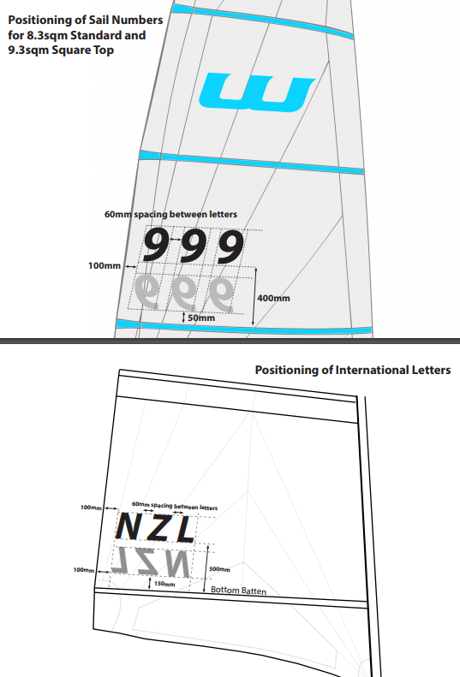 Diagram 1: Location of sail numbers
- A measurer cannot independently measure and certify his or her own boat.
- It is the boat owner’s responsibility at all times to ensure that the hull, beams, floats, foils, rigging, and sails comply with these Class Rules.
- All boats with measurement certificates may be re-measured at the discretion and request of a national Weta association, a race committee, a protest committee, or a representative of a national Weta association. Only an official measurer may conduct and certify a measurement.
- A boat that has been measured and proves to be in breach of the Class Rules may be disqualified from current competition and barred from future competition until re-measurement shows that it complies with the class rules.
- A certificate is cancelled if there is structural alteration or major repairs performed on the boat. Relevant points must be verified by an official measurer.

5 Distinctive Marks
- Sail numbers may be any color as long as they are easily visible.
- Sail numbers are attached to the mainsail, between the 2nd and 3rd batten.
- The sail numbers on the starboard side are located above the numbers on the port side.
- The dimensions of the numerals are as follows:
Character height: 300mm (tolerance +/-10mm )
Character width: 200mm (tolerance +/-10mm), except for the number 1.
Space between: 60mm (tolerance +/-20mm)
- The baselines of the sail numbers are parallel to the second batten.
- The base line for the starboard side number is at 450mm (tolerance +/-20mm) from the second batten from the top of the sail.
- The base line for the port side sail number is at 350mm (tolerance +/-20mm) below the baseline on the starboard side.
- The starting line of characters is perpendicular to the second batten located 100mm (tolerance +/-20mm) to the leach of the mainsail. Starboard and port numbers are aligned with this line.

6 Hulls and decks
- For the purpose of routine maintenance, washing of hull and floats with a generally available cleaning product (detergent, gelcoat cleaner, or similar product), and polishing with a generally available product, is allowed.
- Except in performing typical repairs, adding or removing material to change the shape and enhance performance of the hull and floats is strictly prohibited.
- Inspection hatches can be added to the hull, provided this does not affect the structural integrity of the vessel. Containers or hardware may be installed freely inside these hatches.
- Holes may be drilled in the deck or cockpit of the hull to attach fittings. However, the owner must ensure that this does not weaken the boat or enhance the boat’s performance.
- Material may be adhered to the interior (gelcoat) surface of the dagger board case to reduce lateral movement of the board or reduce passage of water between the case and the board.
- No other addition is permitted below the hull and float waterline apart from the standard hardware used for the rudder and dagger board.

7 Floats and Beams
- Each of the floats must be attached to the hull by the beams, consistent with the original manufacture of the boat. The beams must be fixed and fit together in the main hull, and be easily removable.
- Drilling holes in the beams is forbidden.
- Except to perform repairs or replace hatches, drilling holes in the floats is forbidden.
- Apart from the original system of fastening the trampolines, no mechanical lock between the beams and the hull is allowed.

8 Weight of the boat ready to sail
- Ballast weights, either fixed or removable, are prohibited.
- Regularly moving equipment onboard during a race to enhance performance is prohibited.

9 Dagger Board
- The dagger board is a single-element blade fabricated by Weta Marine or licensed manufacturer.
- Except when performing typical repairs, adding or removing material to change the shape and enhance performance of the dagger board is prohibited.

10 Rudder
- The rudder hinges on the transom of the hull by manufacturer-supplied fittings and includes a device to hold it in place in the event of a capsize.
- In neutral position, the rudder should be in the longitudinal plane of the hull.
- Foils and other appendages attached to the rudder are prohibited.
- Changes in the control system of the rudder are permitted.
- A system for locking the rudder position (shock cord, rope, Velcro) is allowed.
- Any rudder blade which has been supplied by the manufacturer is permitted.
- Except when performing typical repairs, adding or removing material to change the shape and enhance performance of the rudder is prohibited.
- Any number and length of tiller extensions may be attached to the tiller.

11 Mast
- The mast must be supplied by the manufacturer or a licensed distributor.
- Modifications to change the mast length, stiffness, or bend characteristics are forbidden.
- The mast does not include the mast step (base attachment on the deck) but it includes the cap reinforcing the mast foot for boats that are equipped with one.
- The position of the mast step on the deck is fixed and not adjustable.
- The mainsail must not be sailed hoisted above 11cm below the top of the mast head.

12 Standing Rigging
- The standing rigging is composed of two shrouds and a forestay. There shall not be any other standing rigging.
- The shrouds and forestay can be composed of any material except carbon fiber or metal rod of any type.
- The forestay may be secured to the front of the hull by any means.
- The shrouds shall be secured to the floats by manufacturer-supplied fittings, or comparable replacements, that are fixed and un-moveable.
- A shroud length adjustment system is permitted.
- Adjustment of the standing rigging after a boat has started a race is prohibited.

13 Running Rigging
- All halyards to be 4mm diameter minimum. Jib sheets and mainsheet 6mm diameter minimum. Gennaker sheets 8mm diameter minimum.
- Other materials used for running rigging are unrestricted.
- The choice of suppliers and make of the running rigging is unrestricted.
- A clip, shackle, ring or block arrangement may be fitted to the clew eyelets of the jib.
- The entire jib sheets may be of any length and arrangement, and may have a maximum of 2x extra pieces in total of the above mentioned hardware added in order to achieve a 2:1 purchase.
- The mainsheet purchase system may be rigged with alternative blocks and cleats provided it does not exceed a maximum purchase of 6:1. The purchase system must attached to the original factory position on cockpit floor, or if required can be changed (after market) to a fixed center hull position point on a simple nonadjustable rope bridle through combing holes (port and starboard) in perpendicular alignment to the original factory position.
- Two extra turning blocks may be tied to the beam frame for the gennaker sheet system. The gennaker sheet must lead unrestricted from the gennaker clew direct through the factory fitted position of gennaker block, prior to leading to any additional turning blocks added.
- The purchase of the downhaul may be increased to a maximum of 6:1 with additional blocks.
- The use of shock cord or adhesive tape is unrestricted, except that such material must not be used to create a fitting or extend a function which is otherwise prohibited in these rules.
- The removal of the bottom jib hank is permitted.
- The location of the primary cleats or stoppers for the Jib and Gennaker halyards is unrestricted.
- The Main and Gennaker halyards may not be fitted with more than 1:1 purchase.
- The Jib halyard may be arranged to provide up to a 3:1 purchase using a single un-cut length of line and only one loop, block, or thimble.

14 Crew
- There is no minimum weight for the crew.
- Maximum combined crew weight shall not exceed the manufacturer’s rating of 200kg.

15 Sails
- The sails shall consist of a mainsail, a jib, and a gennaker. Only sails fabricated under license by the manufacturer are allowed.
- One set of sails including a mainsail, jib and gennaker is allowed per event. Any replacement of a sail in the same event must be approved by the Chairman of the Race Committee.
- The ISAF rules for measuring sails apply if they do not conflict with or contradict with the Class rules. Sails shall be made from woven or nonwoven material or a combination of both.
- Any repairs that do not affect its dimensions can be carried out on a sail. All eyelets on a sail can be replaced by eyelets of equal or greater size placed as close as possible to their original location(s).
- Telltales can be added to the three sails
- All sails supplied by the manufacturer to date are allowed to be used.
- During a race, the crew is free to rig and set the gennaker and jib, or not. No distinction will be made between the boats according to their sail plan. If the gennaker is rigged on the boat it must remain in hoisted position unless repairs, reattachments, or furling problems have occurred. ie no dropping the gennaker to solely reduce wind drag.

- Jib
- The jib can have up to 3 battens. These battens, if present, must not be wider than 50mm, must be sewn into the sail, and must not be adjustable in position or tension.
- The method of fixing the jib to the forestay is unrestricted. Retractors, furling, or equivalent systems, are allowed.
- The jib shall be carried on the forestay.

15.2 – Main Sail
- The sail shall not have leech tension adjusters
- The mainsail may have a maximum of five battens, provided by any source.
- Battens must not be wider than 50mm and must not extend past the edge of the leech more than 50mm.
- Battens must not have any moving parts. Any kind of batten tips can be used, but batten tension cannot be changed while sailing.
- The mainsail shall be raised with its bolt rope inside the mast track. It must not be fitted with a double track or any alternative system fixing the luff to the mast.
- The main sail shall not extend above the masthead pulley sheave.
- Three eyelets are allowed at the clew of the mainsail. These three eyelets are only allowed to be used to attach the main sheet to the sail.
- Main sail area maximum size is 8.3 square meters.

15.3 - Gennaker
- The gennaker must be rigged between the mast and bowsprit. It is mounted on a roller, or equivalent furling system.
- Use of the optional 12.9 m² Weta gennaker is forbidden from use in one-design racing.

16 Bowsprit
- The bowsprit is a carbon tube, provided by the manufacturer.
- The bowsprit is positioned along the central longitudinal axis of the main hull, extending from the bow.
- The position, extension, and angle of the bowsprit is fixed. Any modification is prohibited.
- The bowsprit must remain in it’s designed socket with a maximum extension of 1150mm from the bow.

17 Miscellaneous
- The following items are prohibited: Jib pole, rigging adjustment rails, jib boom, mainsail boom, boom kicker, hydrofoils, weights, automatic baling, planning strakes, hard chines and any protrusion outside of the hull other than the normal equipment.
- No devices for hiking are allowed apart from foot straps and hand straps. Using a trapeze is prohibited.
- Standing on the floats or trampoline while sailing is prohibited except during a tack or gybe.
- One or more handles may be attached to the shrouds or trampoline edges to assist the crew to get back onto the trampoline from sitting on the float.
- A hiking strap may be attached to the center line of the cockpit between the central D ring and the main sheet anchor fitting.
- The trampolines may have an additional set of hiking straps added to them.
- A safety harness may be worn across the chest and attached to a tether that is anchored to the D-ring in the center of the cockpit floor. The tether must have a quick release system where it attaches to the harness at the front of the body. The harness may be used to support the upper body of the user when hiking from the trampolines or floats.
- Flexible spray deflectors between the front floats and the bow of the hull are permitted, provided they do not prevent a crew from getting into the boat (or that they have a quick release system accessible from the water to allow access). At least 80% of the surface material must be made of mesh similar to the trampolines.
- Parasailing rules – To be added.

18 Mandatory safety equipment while sailing
- Nothing can be modified or removed from a Weta 4.4 that could diminish the structural integrity or safety of the boat.
- The buoyancy and dimensions of the hull and each float provided by the manufacturer must not be changed.
- During a race, the inspection hatches and drain plugs should be in place.
- Each skipper is responsible for carrying aboard the required safety equipment depending on the area of navigation and rules.

19 Optional Equipment
- Electronic instrument displays are restricted to compass course over ground direction heading only.
- FRS, VHF and other communication devices, including cellular and satellite phones, are allowed for safety, but use of these for communication with parties other than the race management during a race is prohibited.
- Electronic beacons, GPS, and other navigation equipment or safety systems are allowed for recording or safe navigation purposes only.
- Electronic equipment may, however, be expressly forbidden by the regatta sailing instructions. The Principal Race Officer may permit or deny the use of electronic equipment in accordance with the sailing instructions.
- Telltales on the stays, wind indicators, barometers, compasses or any other equivalent mechanical equipment are permitted as long as they do not act directly on the foils or sails.
- Calibration marks of any kind are allowed
- Maps, charts and means of recording courses and compass headings may be carried.
- Shock cord tails in ropes are unrestricted.
- Storage devices within the cockpit are allowed.
- Non-skid tape or patches are allowed, provided they are made from a flexible material and attached to the deck molding.
- Safety equipment, tools, and spare parts may be carried.

20 REPAIRS AND REPLACEMENTS
- In the event of damage to any part of the boat, necessary repairs may be made provided they are made in such a way that the essential shape and function is not materially affected.
- Fittings shall be attached in the same position as before the repair, or as close as is structurally possible.
- No part of a boat shall be replaced during an event, other than to replace equipment damaged beyond repair before the next race. Such replacements may be made only with the approval of the race committee, and no re-substitutions of the original equipment may then be made, except with the approval of the race committee.
- Except where specified previously, replacement fittings from any supplier may be used.
- Replacements shall be fitted in the same position as the standard fitting, or as close as is structurally possible.
- Any cleat may be replaced with a cleat of any material and of substantially the same size and design.
- Any block may be replaced with a block of the same number of sheaves of similar or greater diameter.
- The gennaker furler (and jib furler, if any) may be replaced with any other furler.
- The standard supplied multi-hole adjusting plate on each shroud may be replaced with an alternative adjusting device and the shroud length changed as required.
- The main sheet may be attached to the jib sheet with the use of an eyelet or knot.

21 Grandfathering Clause
- All Weta 4.4 trimarans built and distributed before hull number 1000 are allowed to run in all Weta 4.4 races with their original hull, floats, mast, rudder, dagger board, rigging, trampolines and sails.
- No changes made by subsequent licensed builders shall make previous boats illegal.
- Older boats are free to replace original equipment with any from licensed suppliers and builders.

23 Appendices

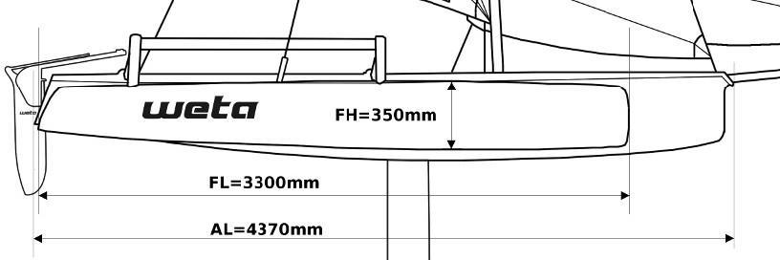
Appendix I – Hull Dimensions
Diagram 2: Dimensions of hulls – side view

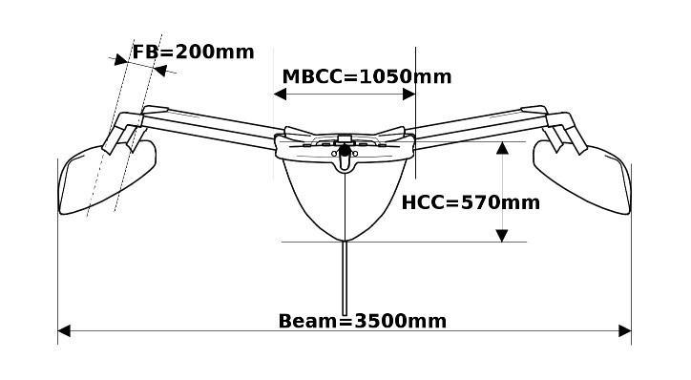
Diagram 3: Dimension of Hulls – Front view

Dimensions of hulls | Minimum | Average | Maximum
AL - Total overall length of the central hull | 4330mm | 4370mm | 4410mm
Beam - Width of the boat amidships measured with taut rigging | 3400mm | 3500mm | 3600mm
MBCC - Width of the central hull amidships | 1030mm | 1050mm | 1070mm
HCC - Height between the base of the mast, and the lowest point of the central hull | 540mm | 570mm | 600mm
FL - Length of a float | 3280mm | 3300mm | 3320mm
FH - Maximum height of a float | 180mm | 200mm | 220mm
Weight of the central hull, screwed fittings included. | 67Kg | - | -
Weight of a float without trampoline and fittings | 17.5Kg | - | -
Minimum weight of the boat seaworthy, dry and clean, with 3 sails and running rigging, excluding safety or other equipment | 120Kg | 125Kg | -

Appendix II - Dimensions of the rudder and Dagger Board.
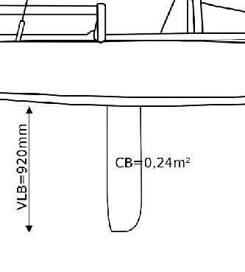
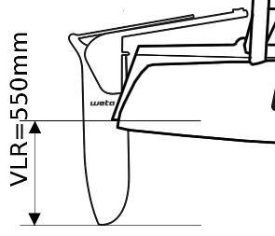

Diagram 4: Dimensions of the rudder Diagram 5: Dimensions of the Dagger Board

Dimensions of the Rudder and Dagger Board | Minimum | Average |  | Maximum
VLR - Maximum immersed length of the rudder | 0mm |  | - | 550mm
RS - Submerged surface of the rudder | 0.05m² |  | 0.09m² | 0.10m²
VLB - Maximum submerged length of the dagger board under the hull | 0mm |  | - | 920mm
CB - Maximum area of the dagger board submerged under the hull | 0.00m² |  | 0.24m² | 0.34m²

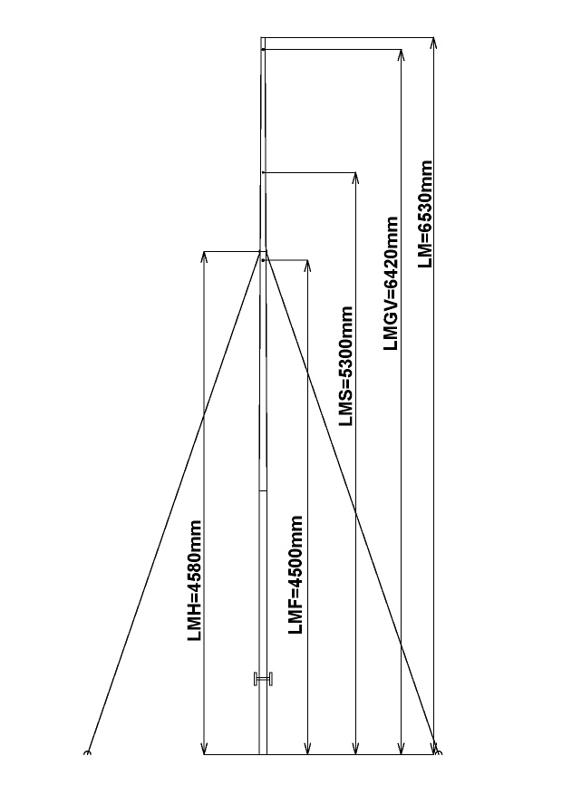
Appendix III – Dimensions of the mast

Diagram 6: Dimensions of the mast

Dimensions of the mast | Minimum | Average | Maximum
LM - Maximum length of the mast | - | 6530mm | 6560mm
MBD - Diameter of the base of the mast | 69mm | 70mm | 71mm
MHD - Diameter of the masthead | 34mm | 35mm | 36mm
LMS - Height of the spinnaker halyard | 5250mm | 5300mm | 5350mm
LMF - Height of the jib halyard | 4450mm | 4500mm | 4550mm
LMGV - Height of the main halyard | 0mm | 6420mm | 6450mm
LMH - Attachment point for 2 shrouds and forestay | 4550mm | 4580mm | 4610mm

Appendix IV – Dimensions of the sails
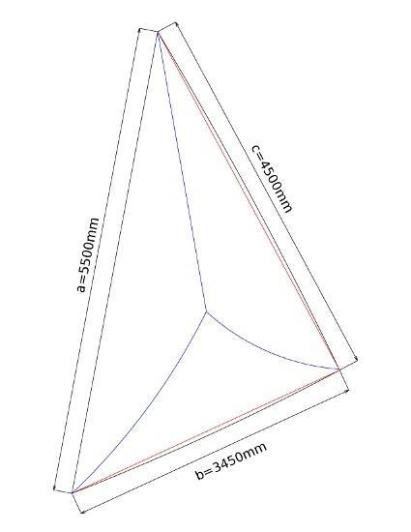
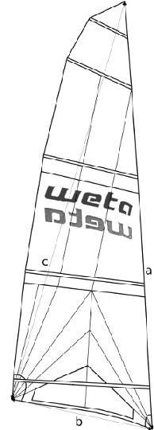
Diagram 7: Dimensions of Main Sail Diagram 8: Dimensions of the Gennaker

Dimensions of the Sails | Minimum | Average | Max
aJib - Luff of the Jib | 0mm | 4450mm | 4480mm
bJib - Foot of the Jib | 0mm | 1540mm | 1570mm
cJib - Leach of the Jib | 0mm | 4030mm | 4060mm
SJib - Surface of the Jib | 0m² | 3.18m² | 3.28m²
aMainSail - Luff of the Main Sail | 0mm | 6100mm | 6140mm
bMain Sail - Foot of the Main Sail | 0mm | 1950mm | 1990mm
cMain Sail - Leach of the Main Sail | 0mm | 5950mm | 5990mm
SMain Sail - Surface of the Main Sail | 0m² | - | 8.30m²
aSPI - Luff of the Gennaker | 0mm | 5500mm | 5600mm
bSPI - Foot of the Gennaker | 0mm | 3450mm | 3550mm
cSPI - Leach of the Gennaker | 0mm | 4500mm | 4600mm
SSPI - Surface of the Gennaker | 0m² | 8.0m² | 8.3m²

Appendix V - Dimensions of the bowsprit
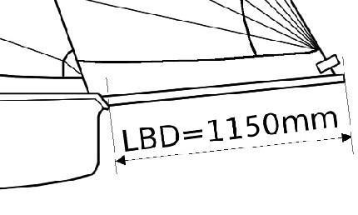
Diagram 9: Dimensions of the bowsprit

Dimensions of the bowsprit | Maximum
LBD - Length of bowsprit protruding from the central hull | 1150mm

